**AWS- Auto Scaling Practical**

**Sharayu chavan**

**10/09/24**

**Name**: - Autoscaling ensures your application stays available by adjusting resources as needed.

* **Step 1: - Create launch template configuration.**
* Choose Amazon Linux as the AMI.
* Select the t2.micro instance type.
* Choose a key pair.
* Configure the security group. (efs_demo)
* Assign a IAM role with access of S3FullAccess.
* In advanced settings, add a bootstrap script. (Copy S3 file)
* Create the launch template

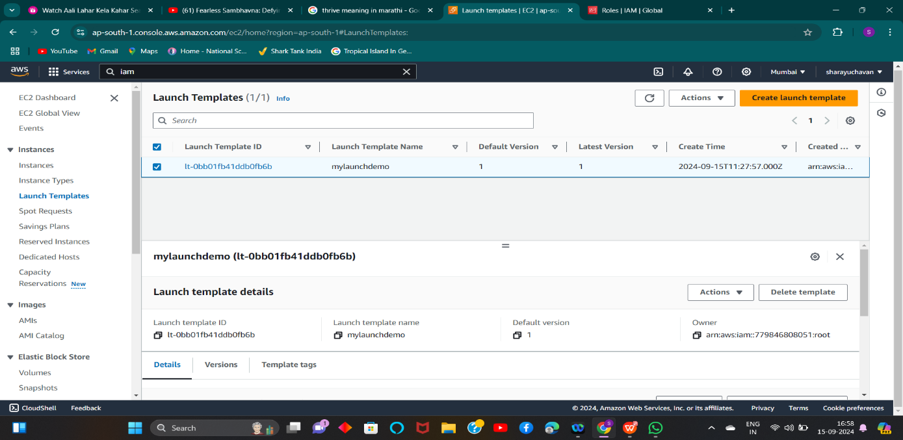

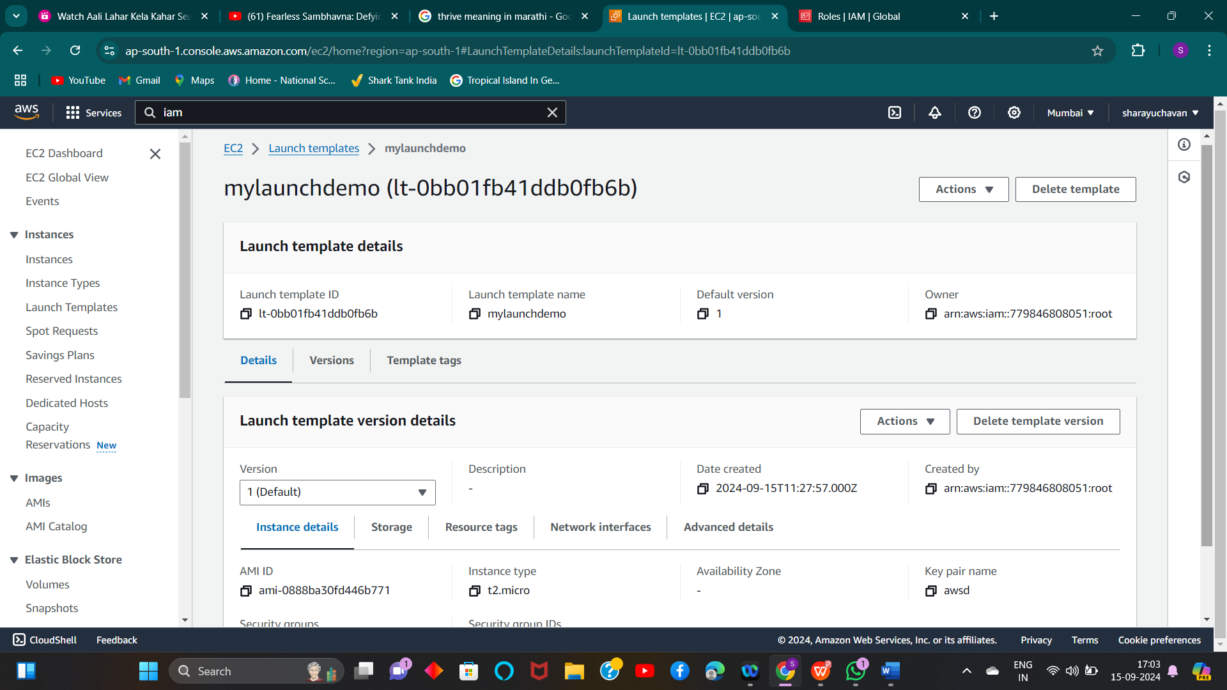

Step 2

1) **Create Autoscaling Group**

1) Provide group name and select template which is created 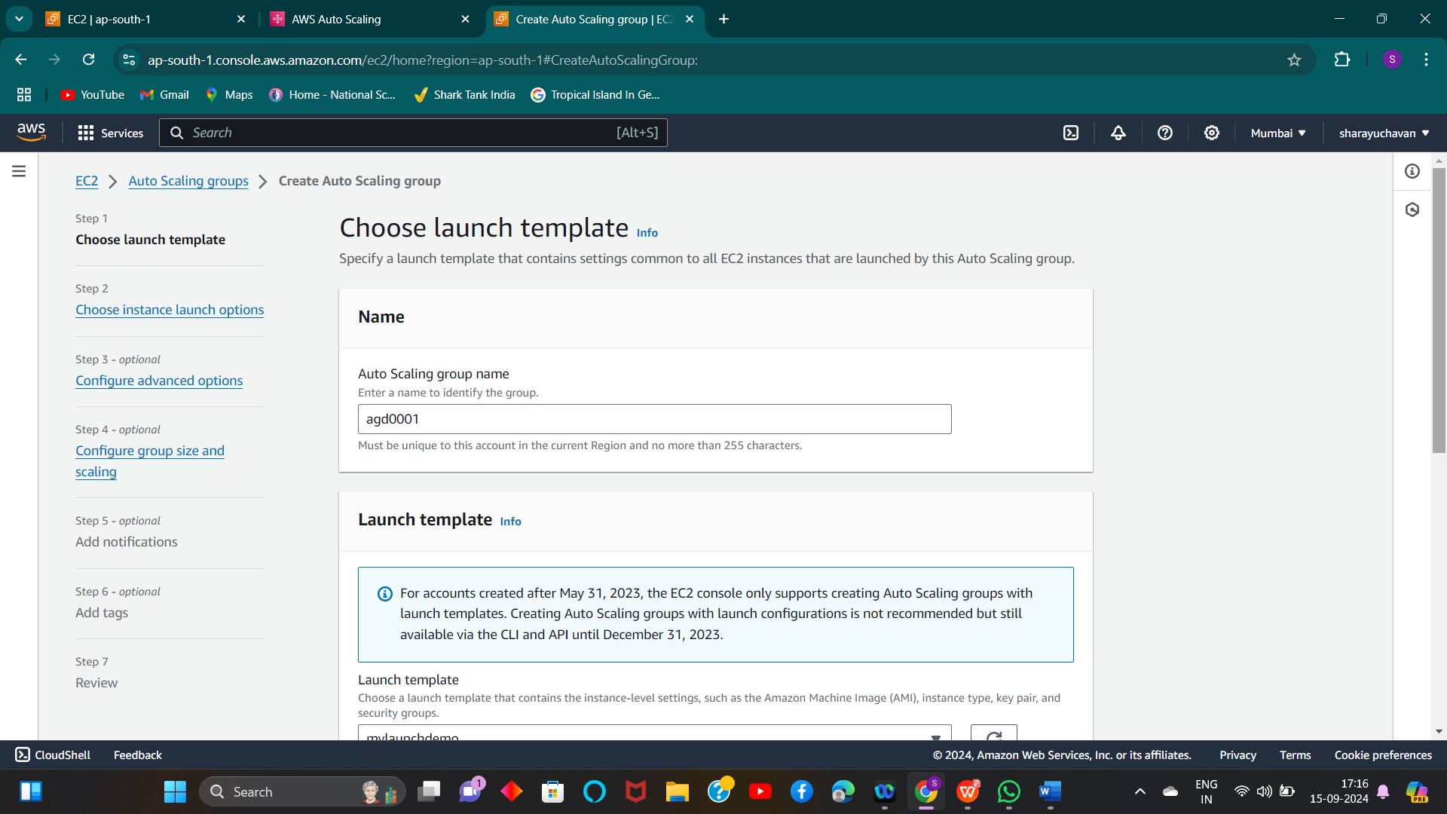

2) Select Availability Zone which you want to create instance

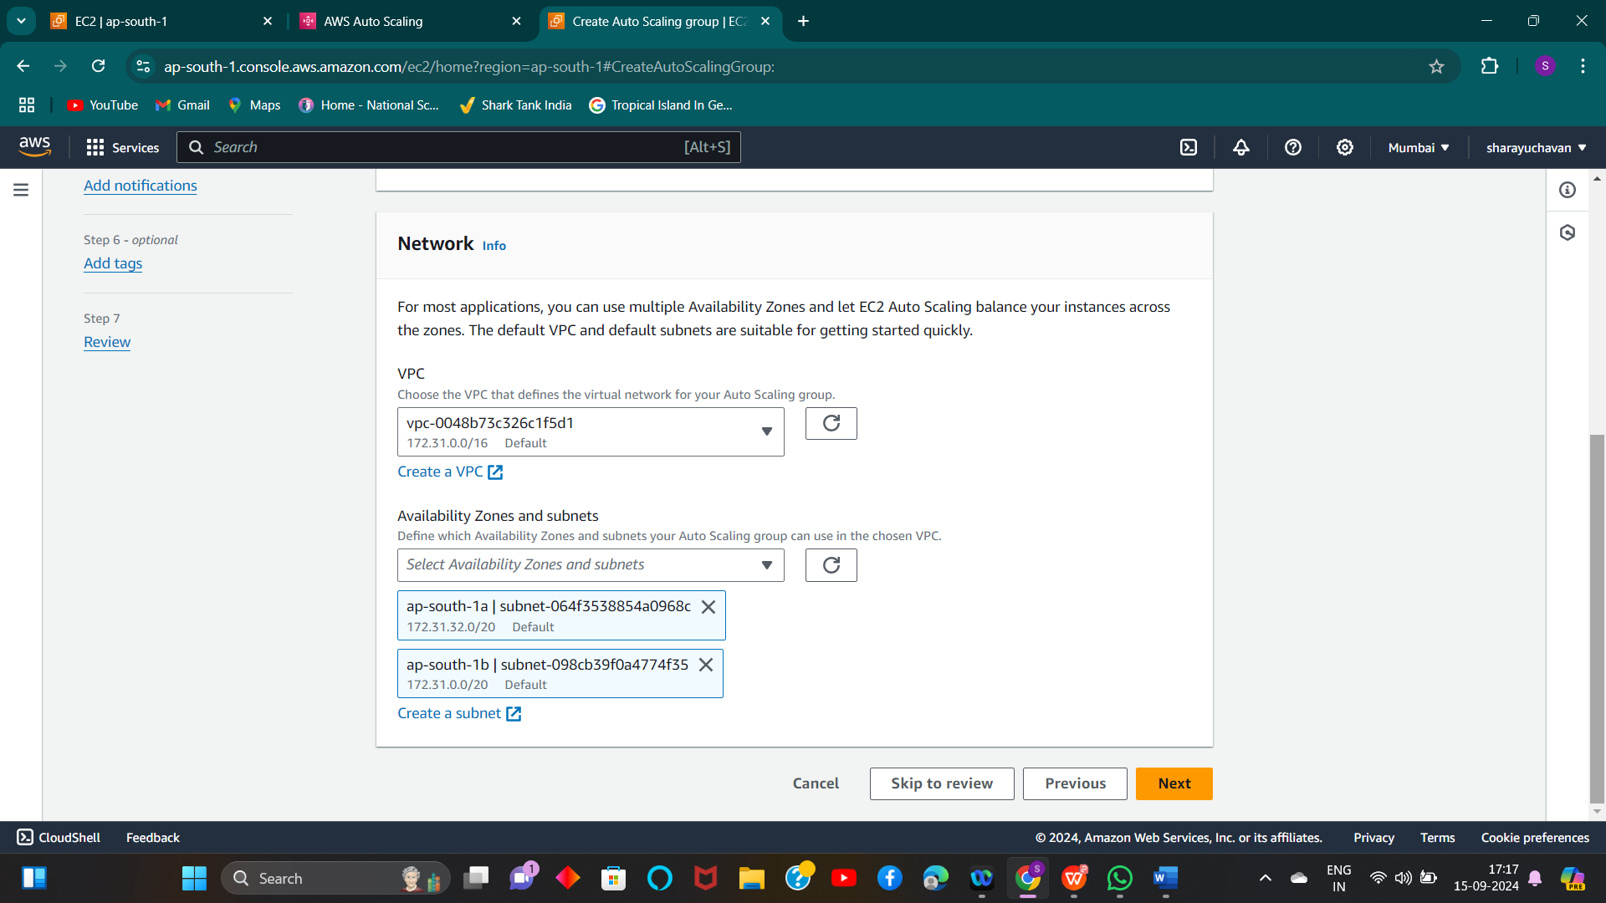

3) Configured group size and scaling as per requirement

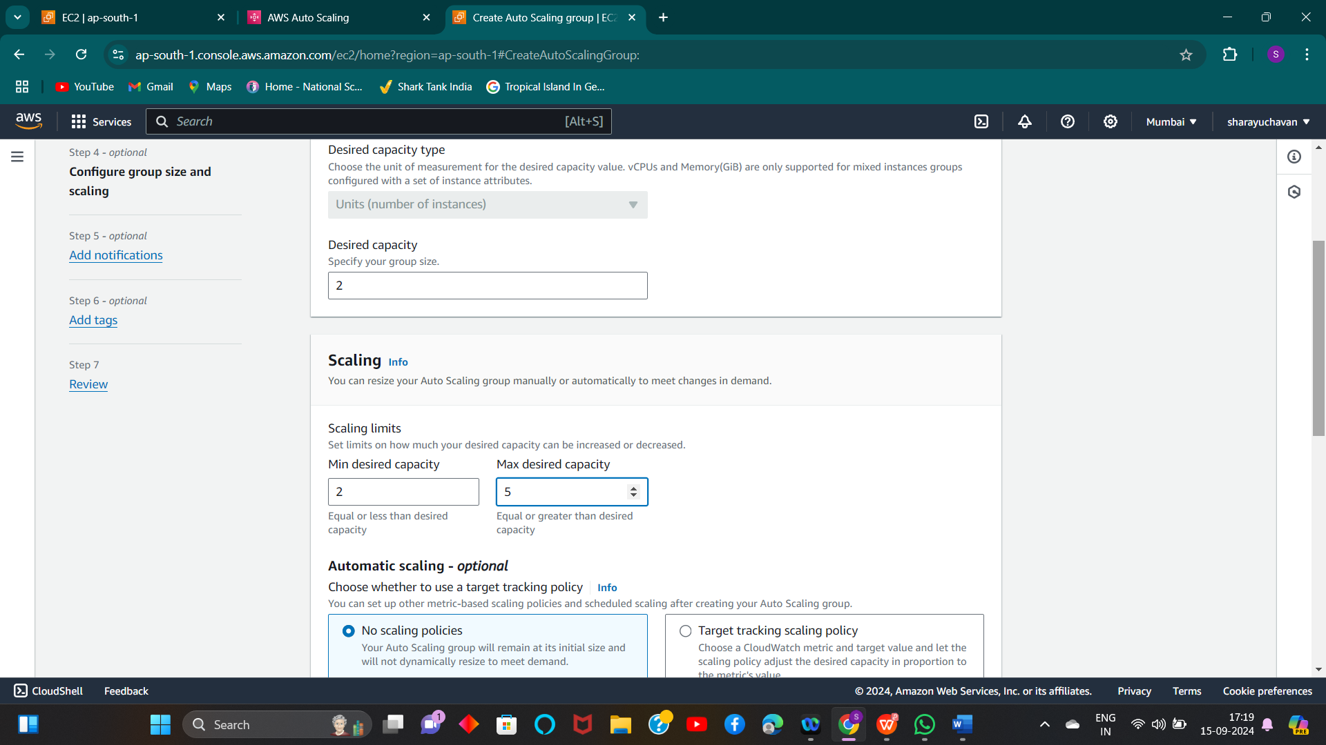

4) ) Autoscaling group have been created

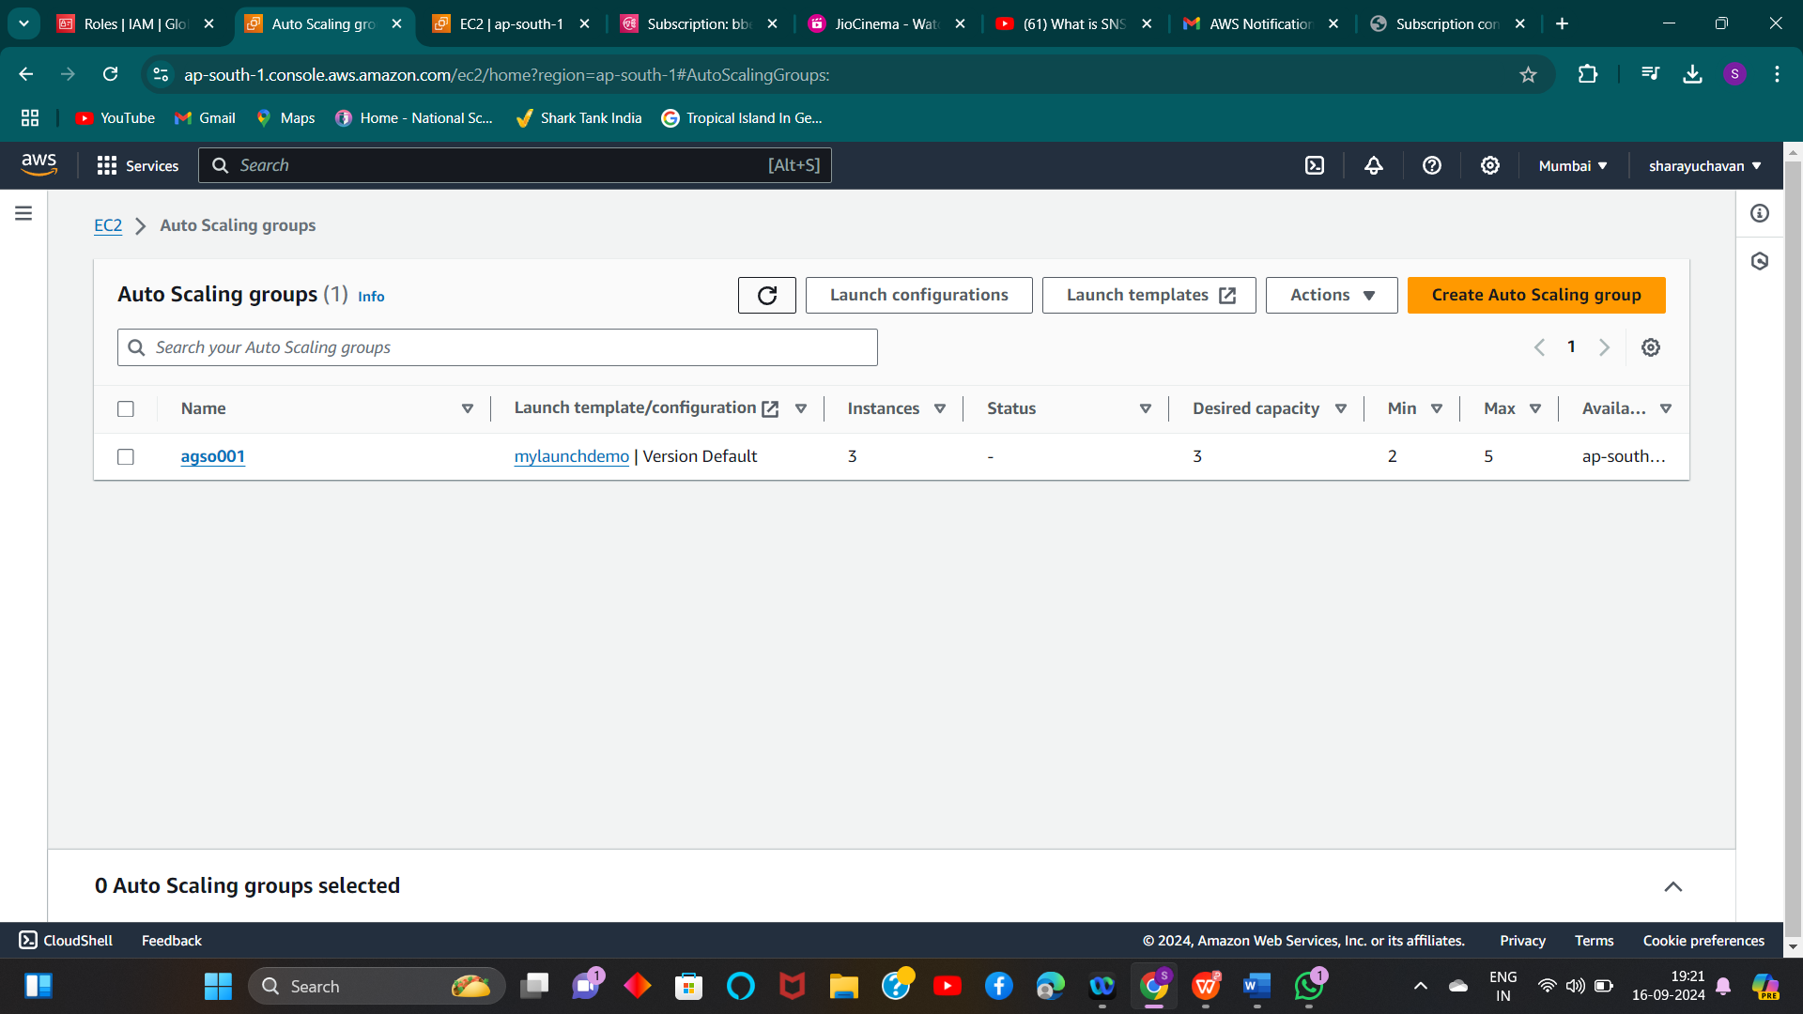

5) Autoscaling group have been created 3 instances as we mentioned in desire “3” count

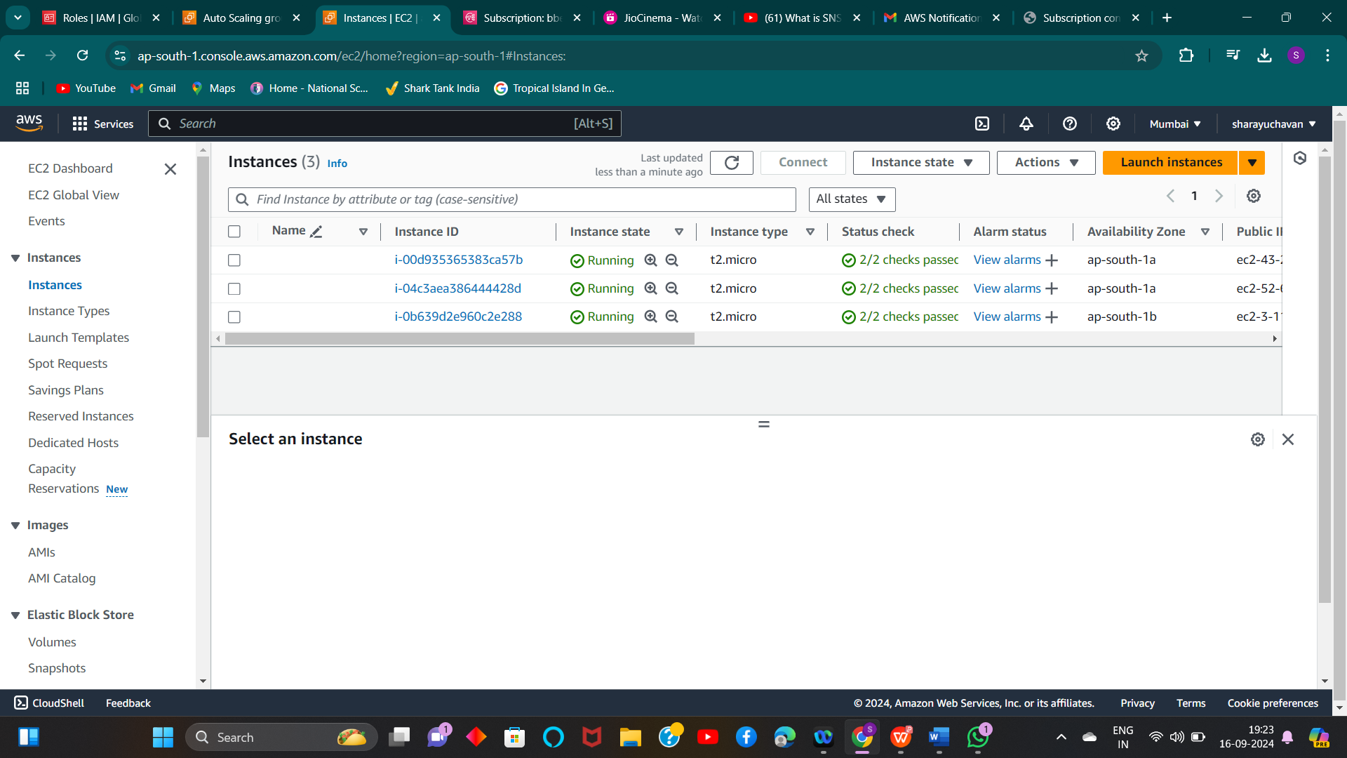

**Manual scaling**

**1)- If I manually change the desired value to 2 from 3, the Autoscaling group will remove 1 instance**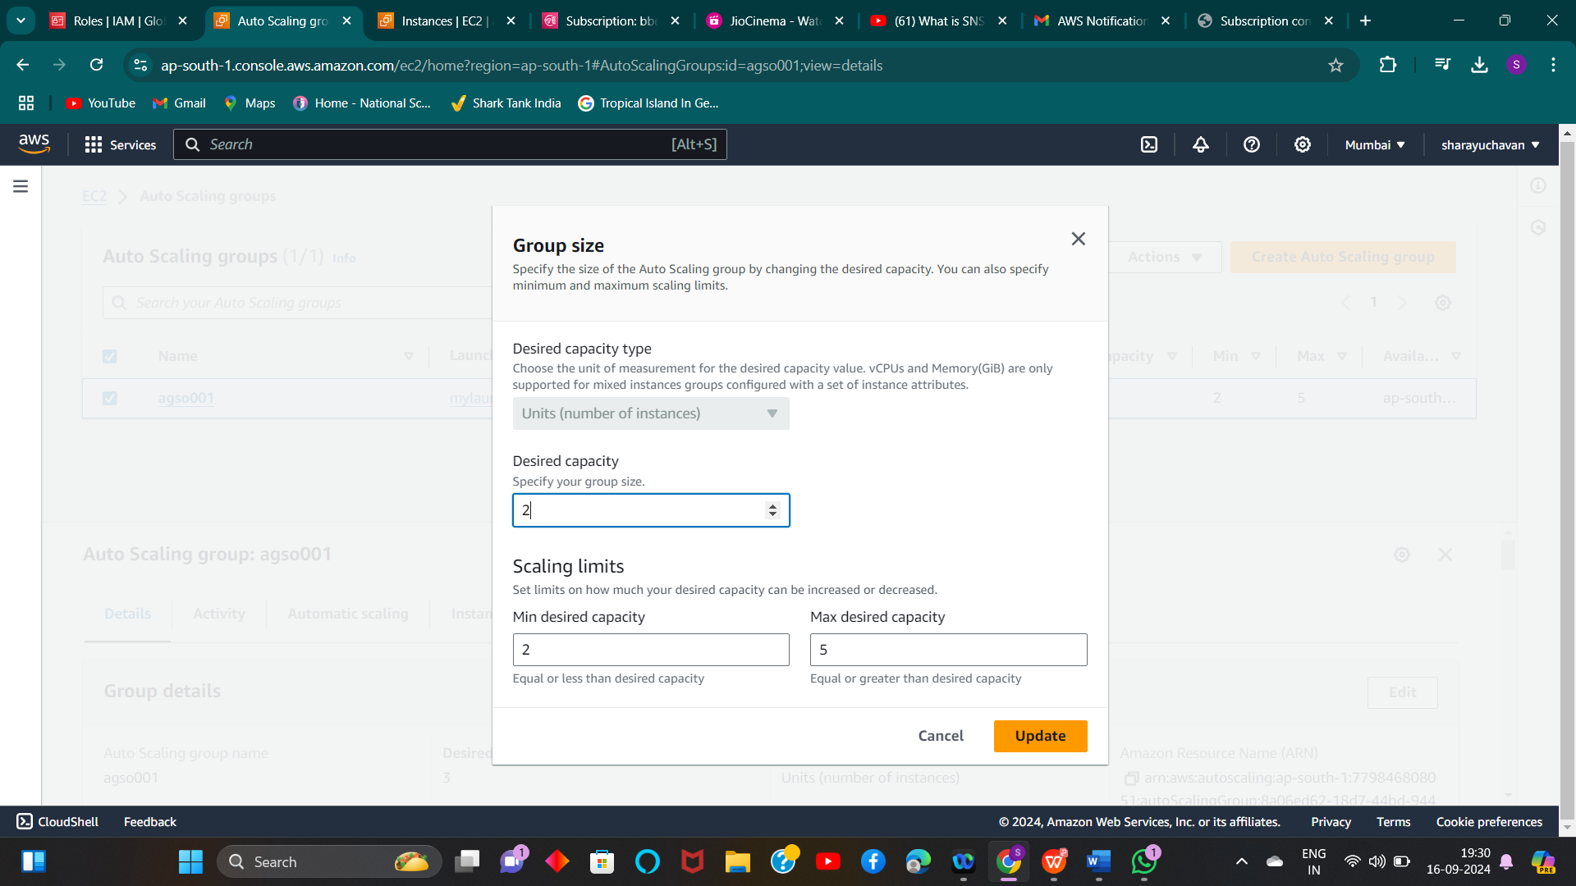

1. **We can see one instance is going to terminate**

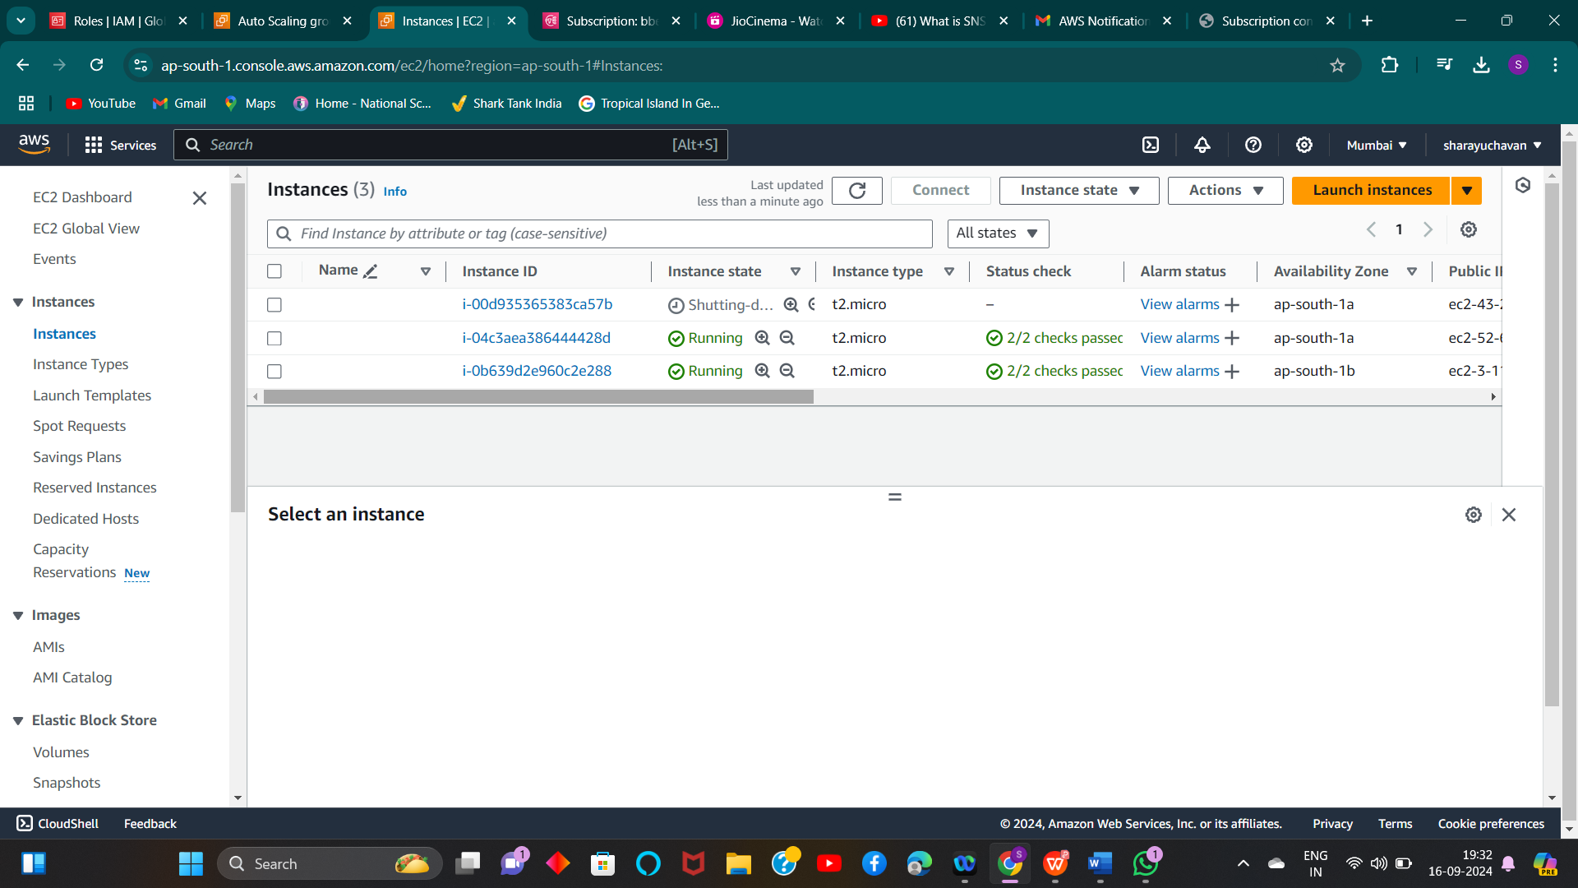

**Automatic scaling**

**We required alarm to set create “Dynamic scaling policies” 1) Create alarm for Autoscaling group (Increase)**

1. **Select metrics (CPU Utilization) and time period “1 min” and threshold value (utilization>50)**

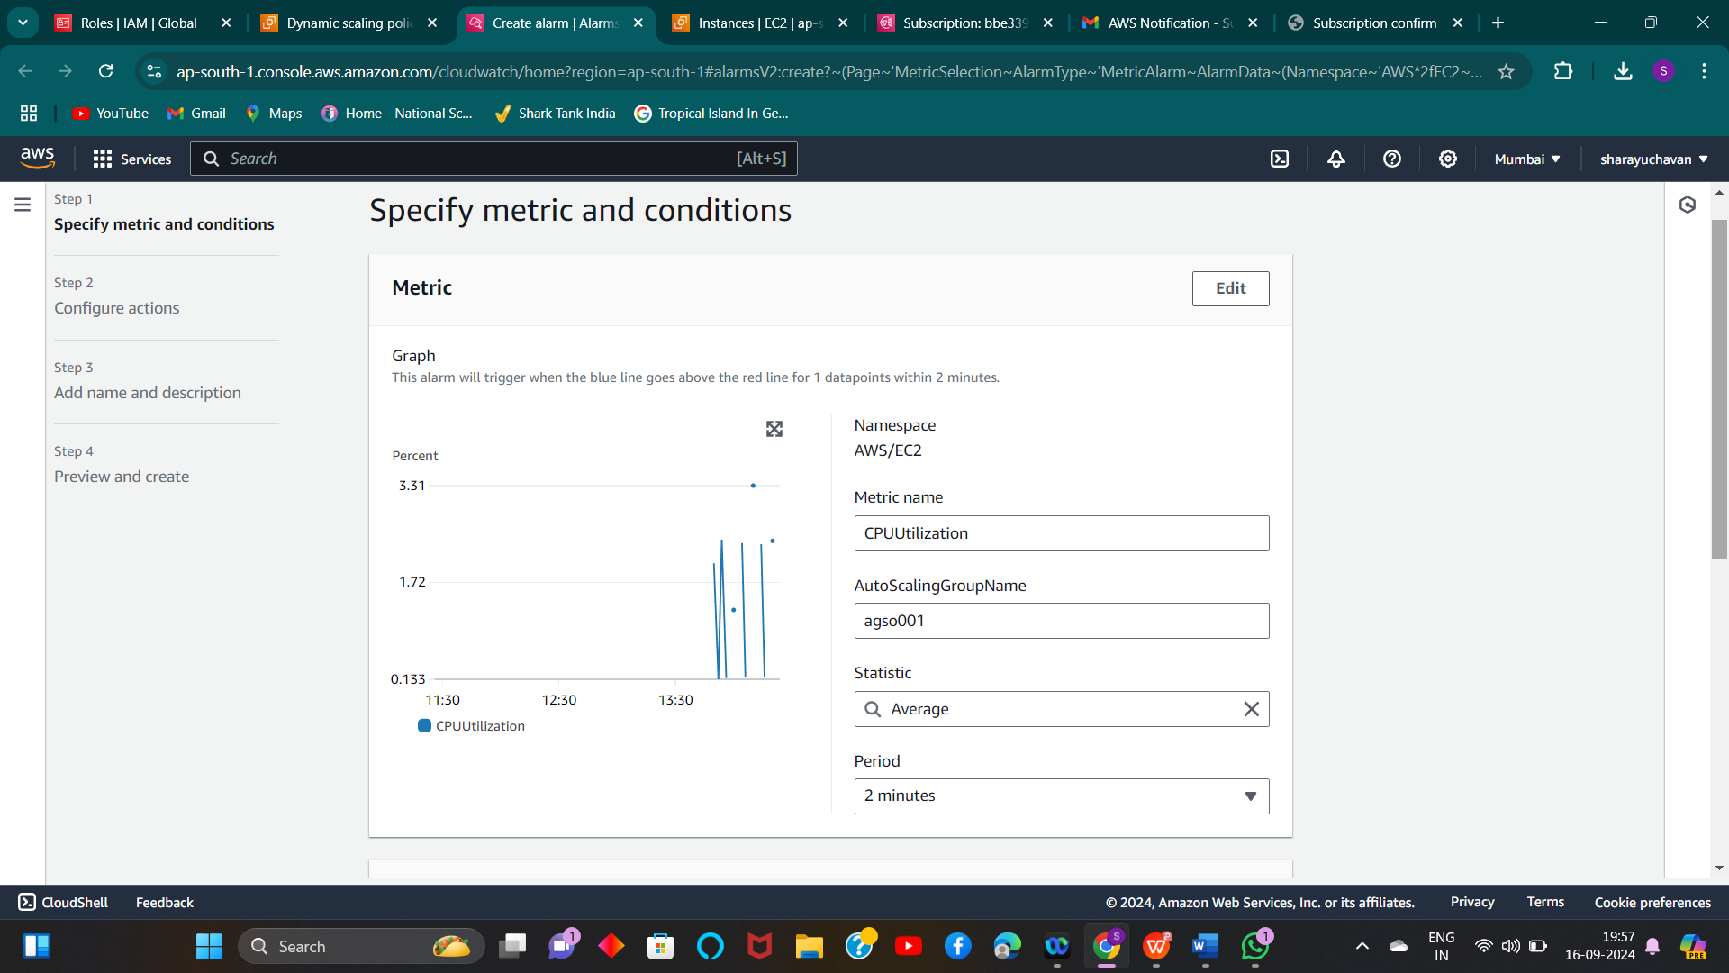

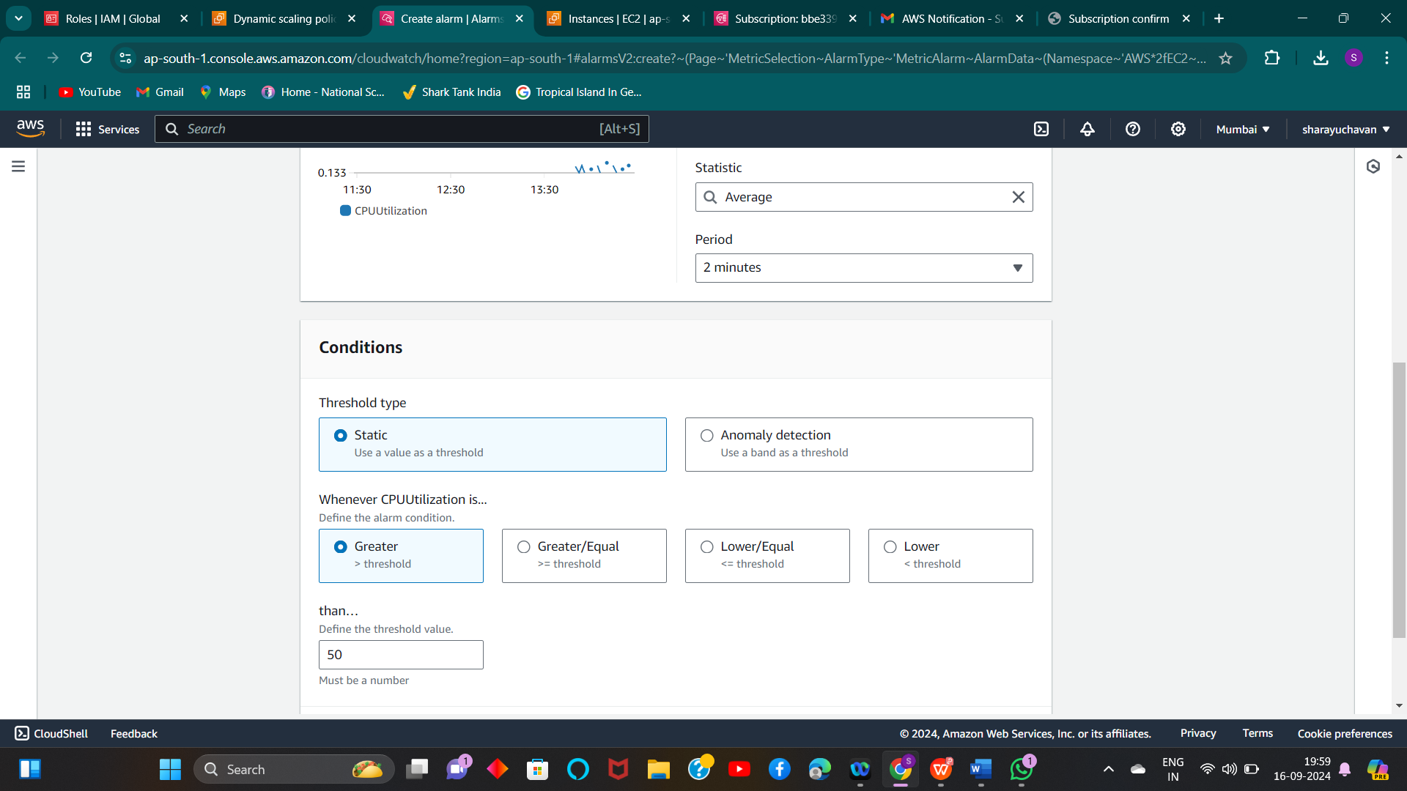

**2)** **Select in which state you want to trigger “In alarm” and add SNS topic**

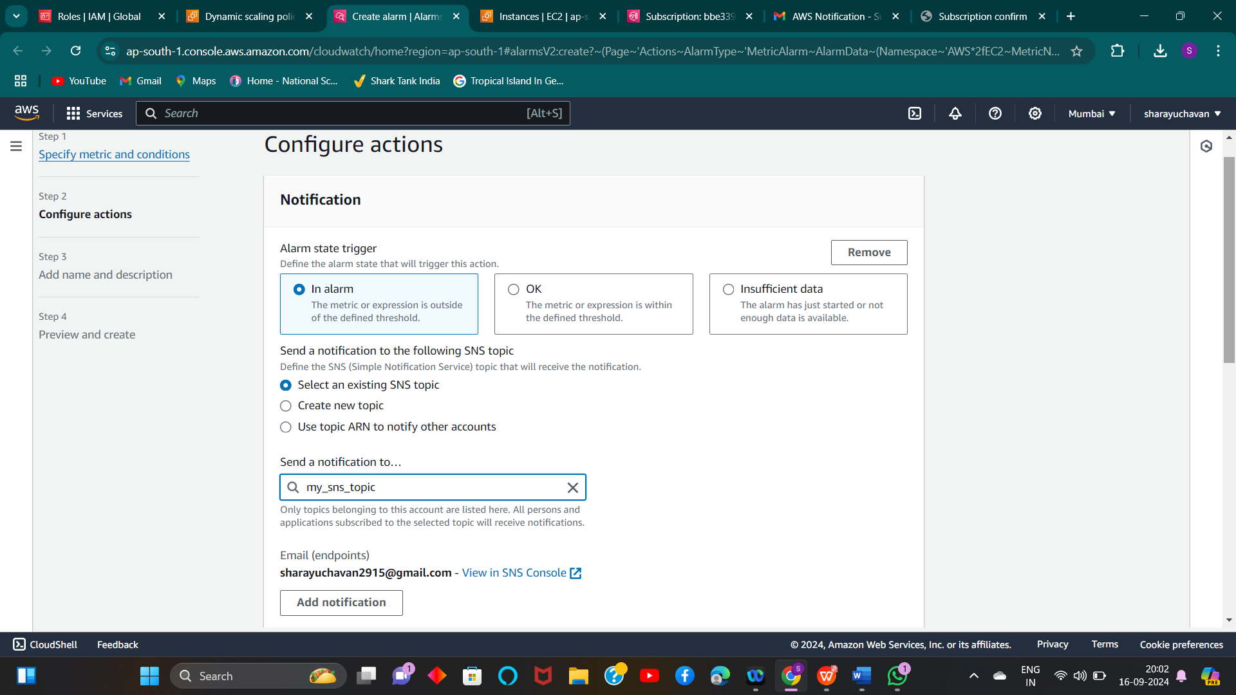**3)** **Alarm is created successfully**

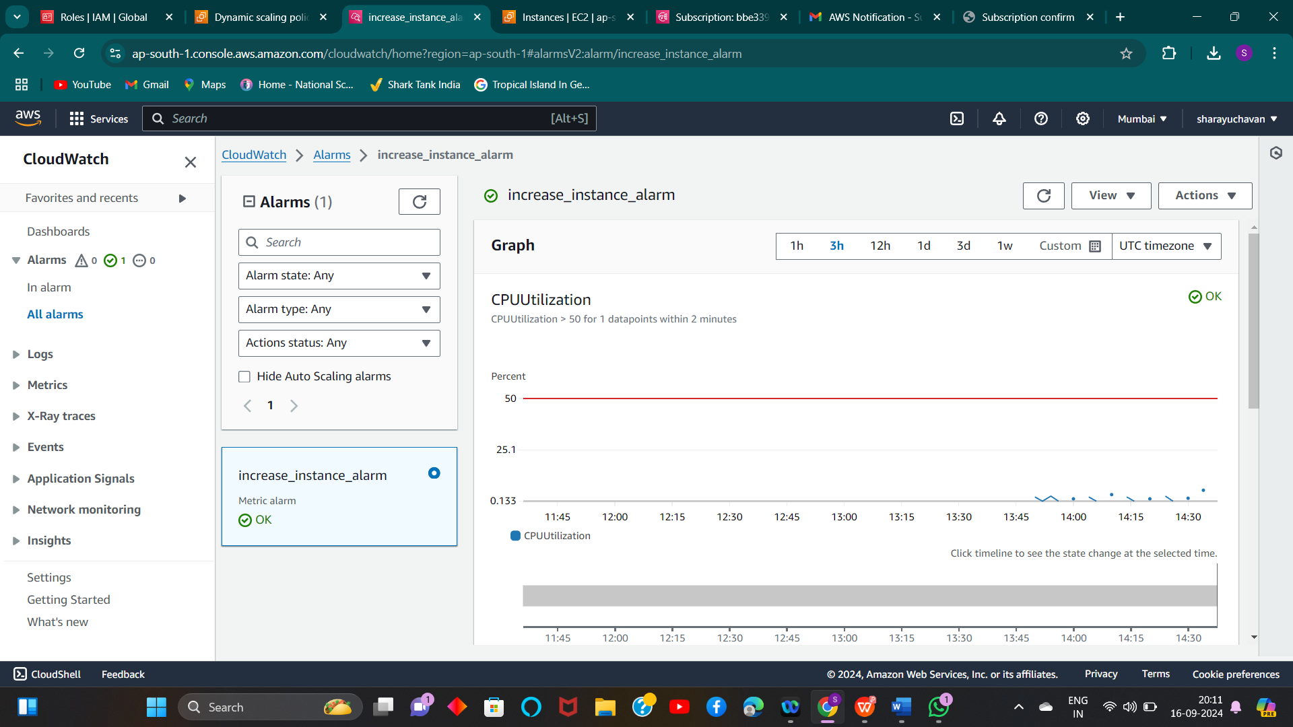

**4)** **Create Dynamic Policy with alarm in take action added count as “1”. It means if utilization is goes above**

**threshold i.e. 50% it should add one more instance.**

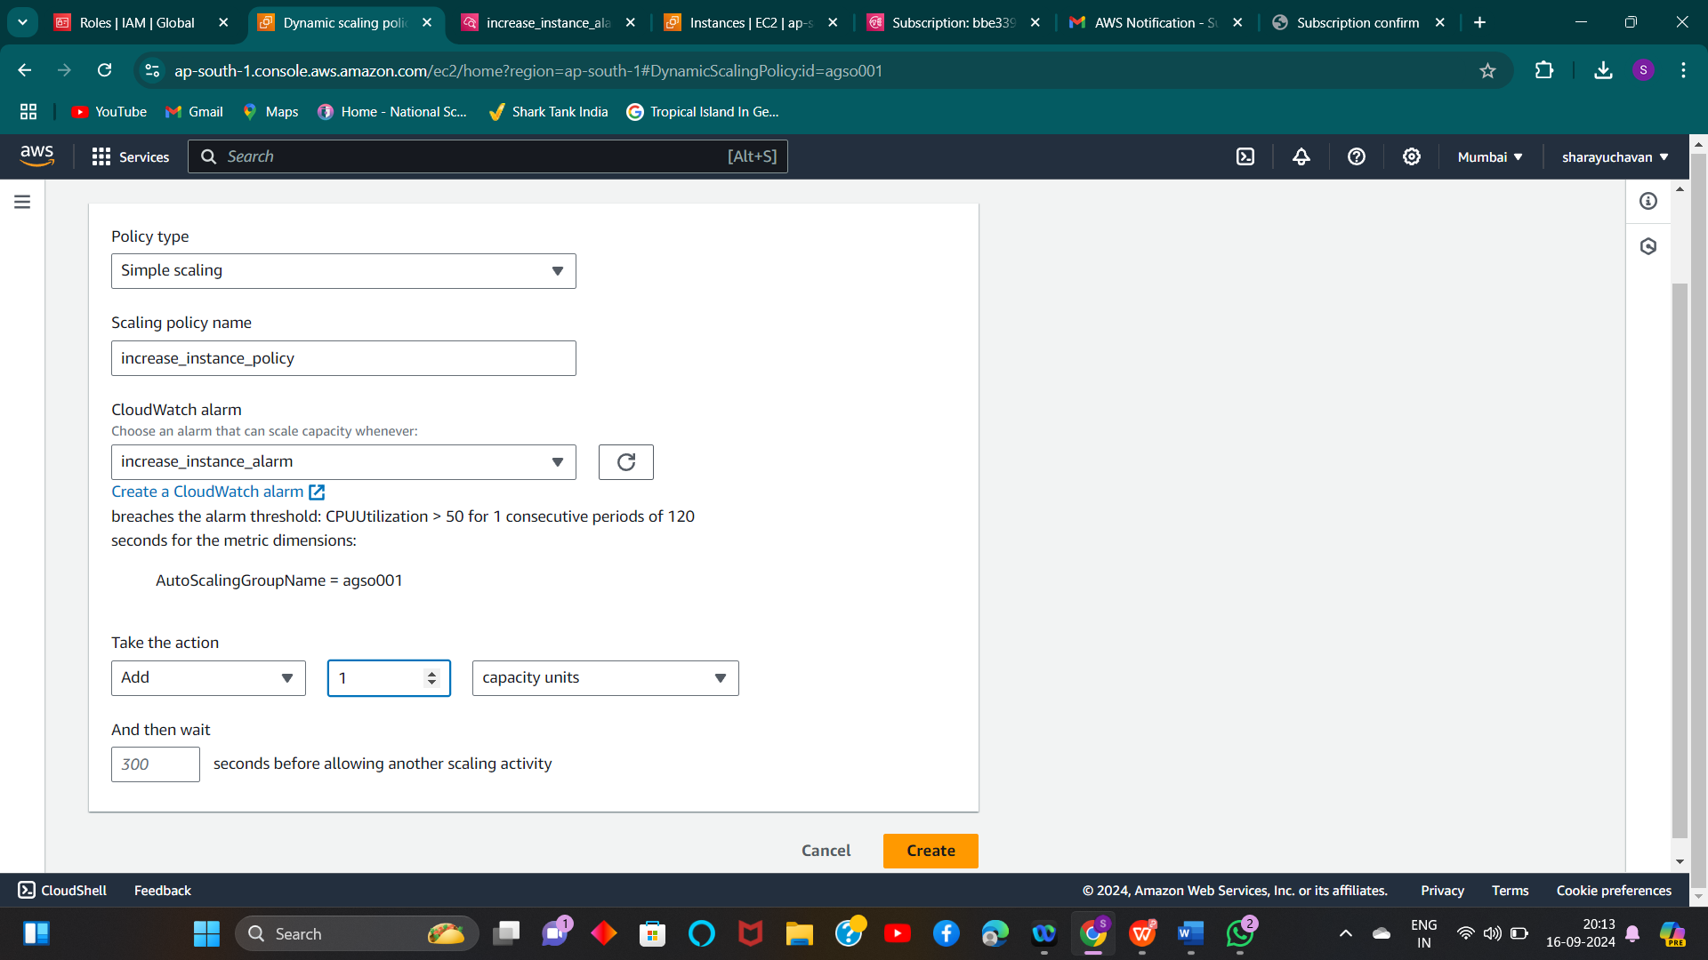

**5)** **Created Dynamic policy as “Increase_instance”**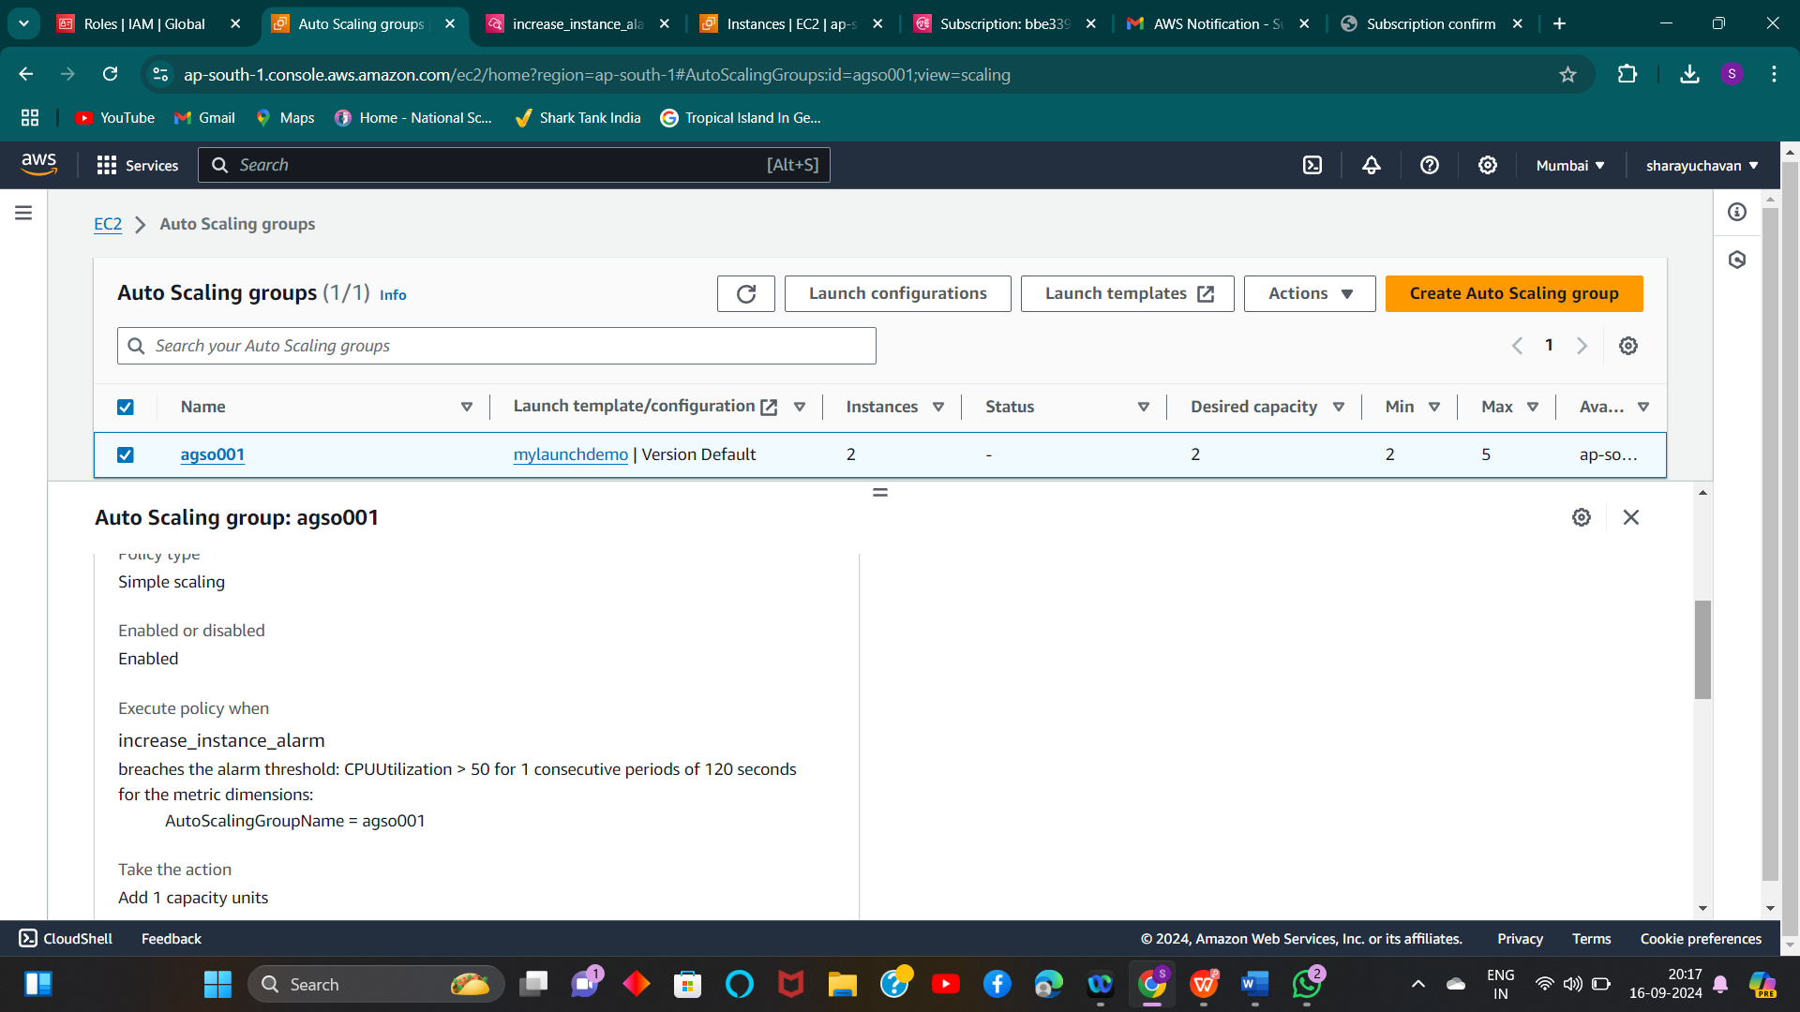

**6) Create Alarm for one more dynamic policy we need to create one more alarm as**

**“Decrease_instance” Now condition is (if CPU utilization is below 20% it should trigger the alarm)**

**1)** **Create alarm**

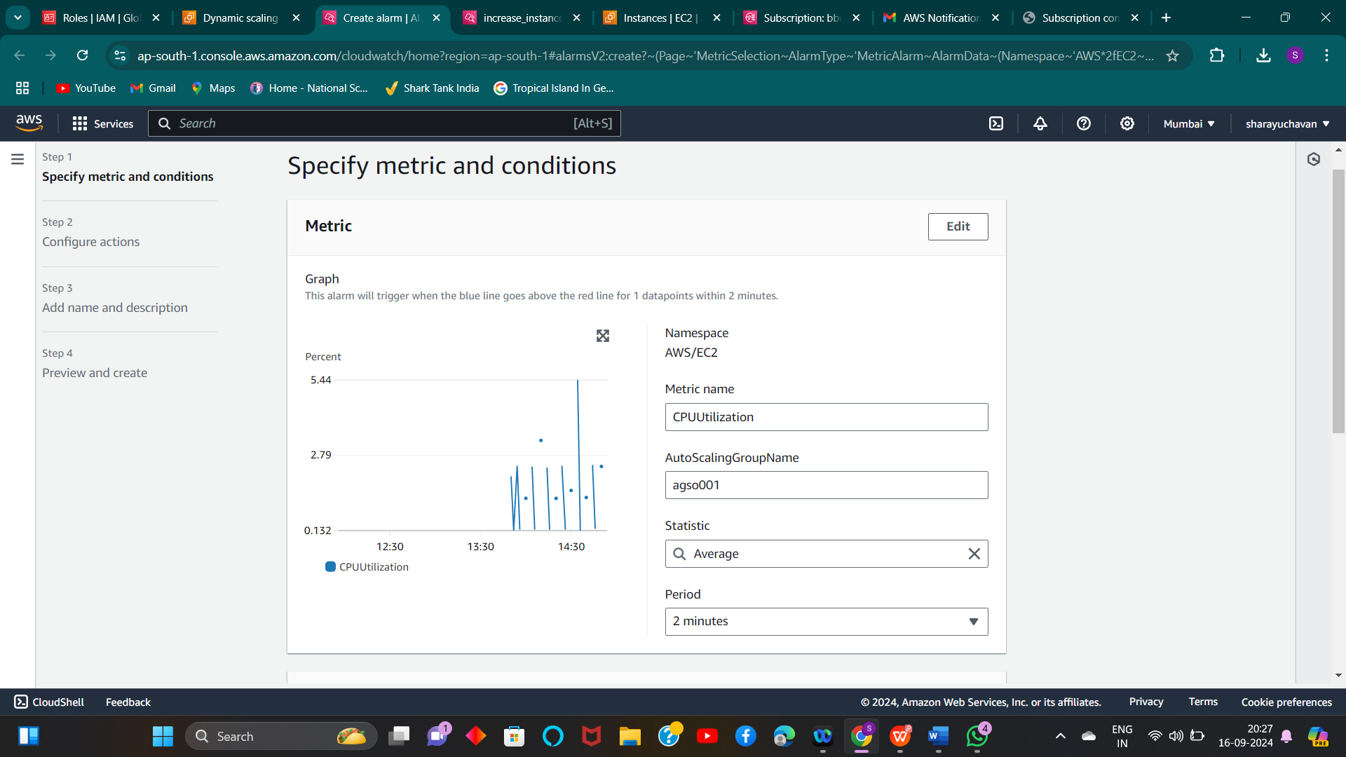

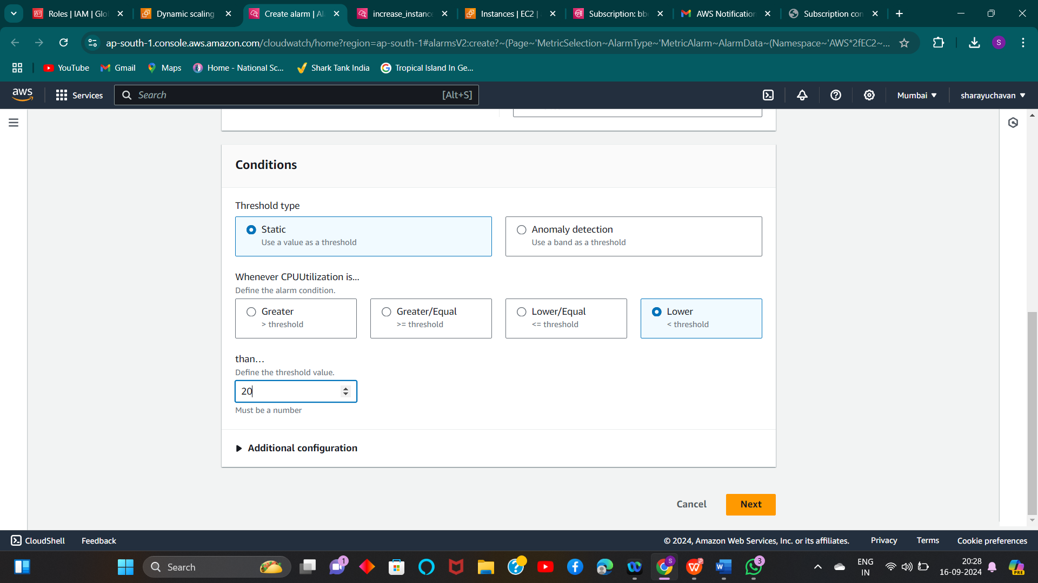

1. **Alarm is created**

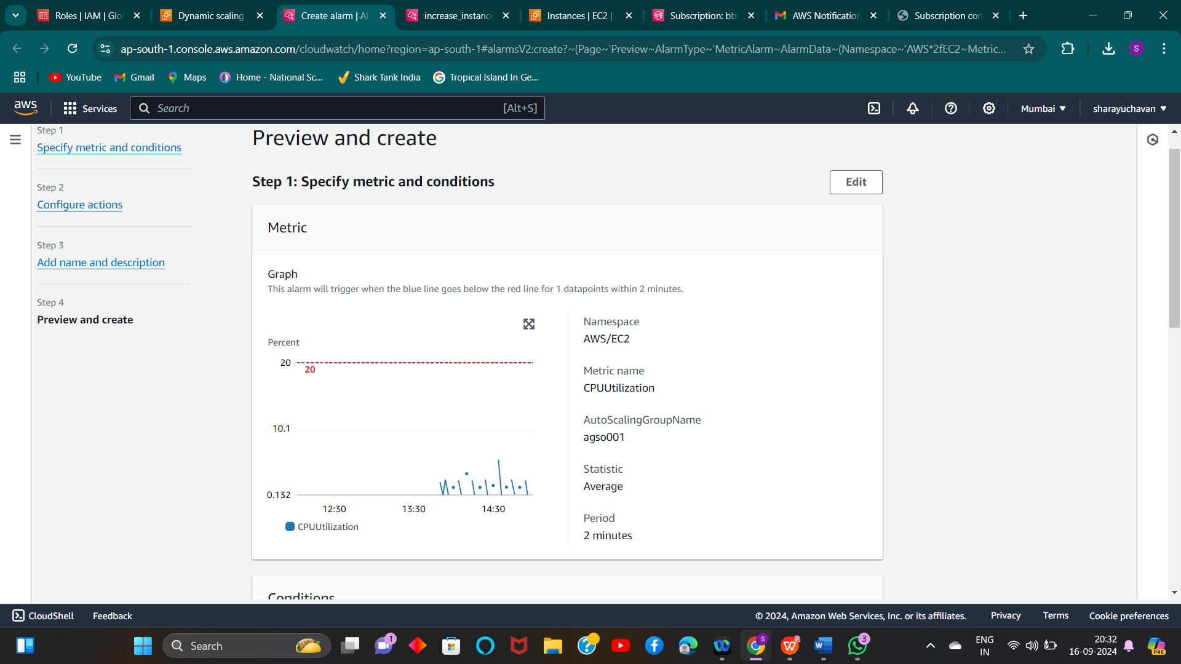

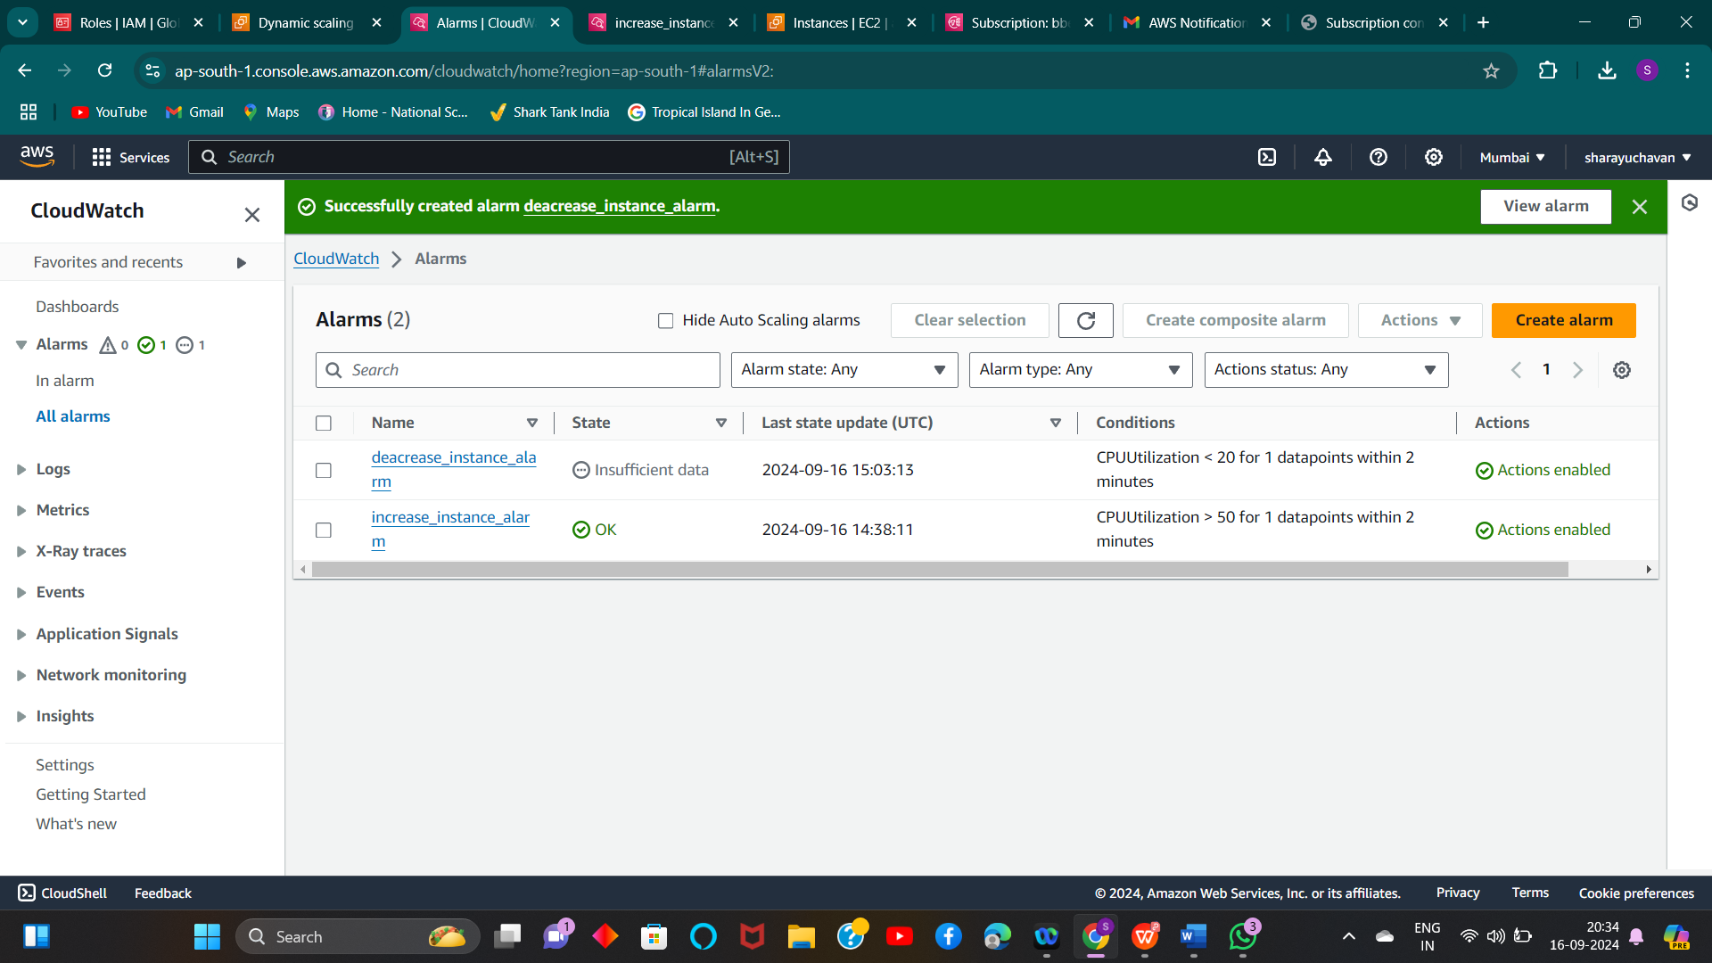

**3) Create policy as “decrease_instance” in take action select “Remove” and count as “1” It means**

**if utilization is below its threshold i.e. 20% it should remove one instance**

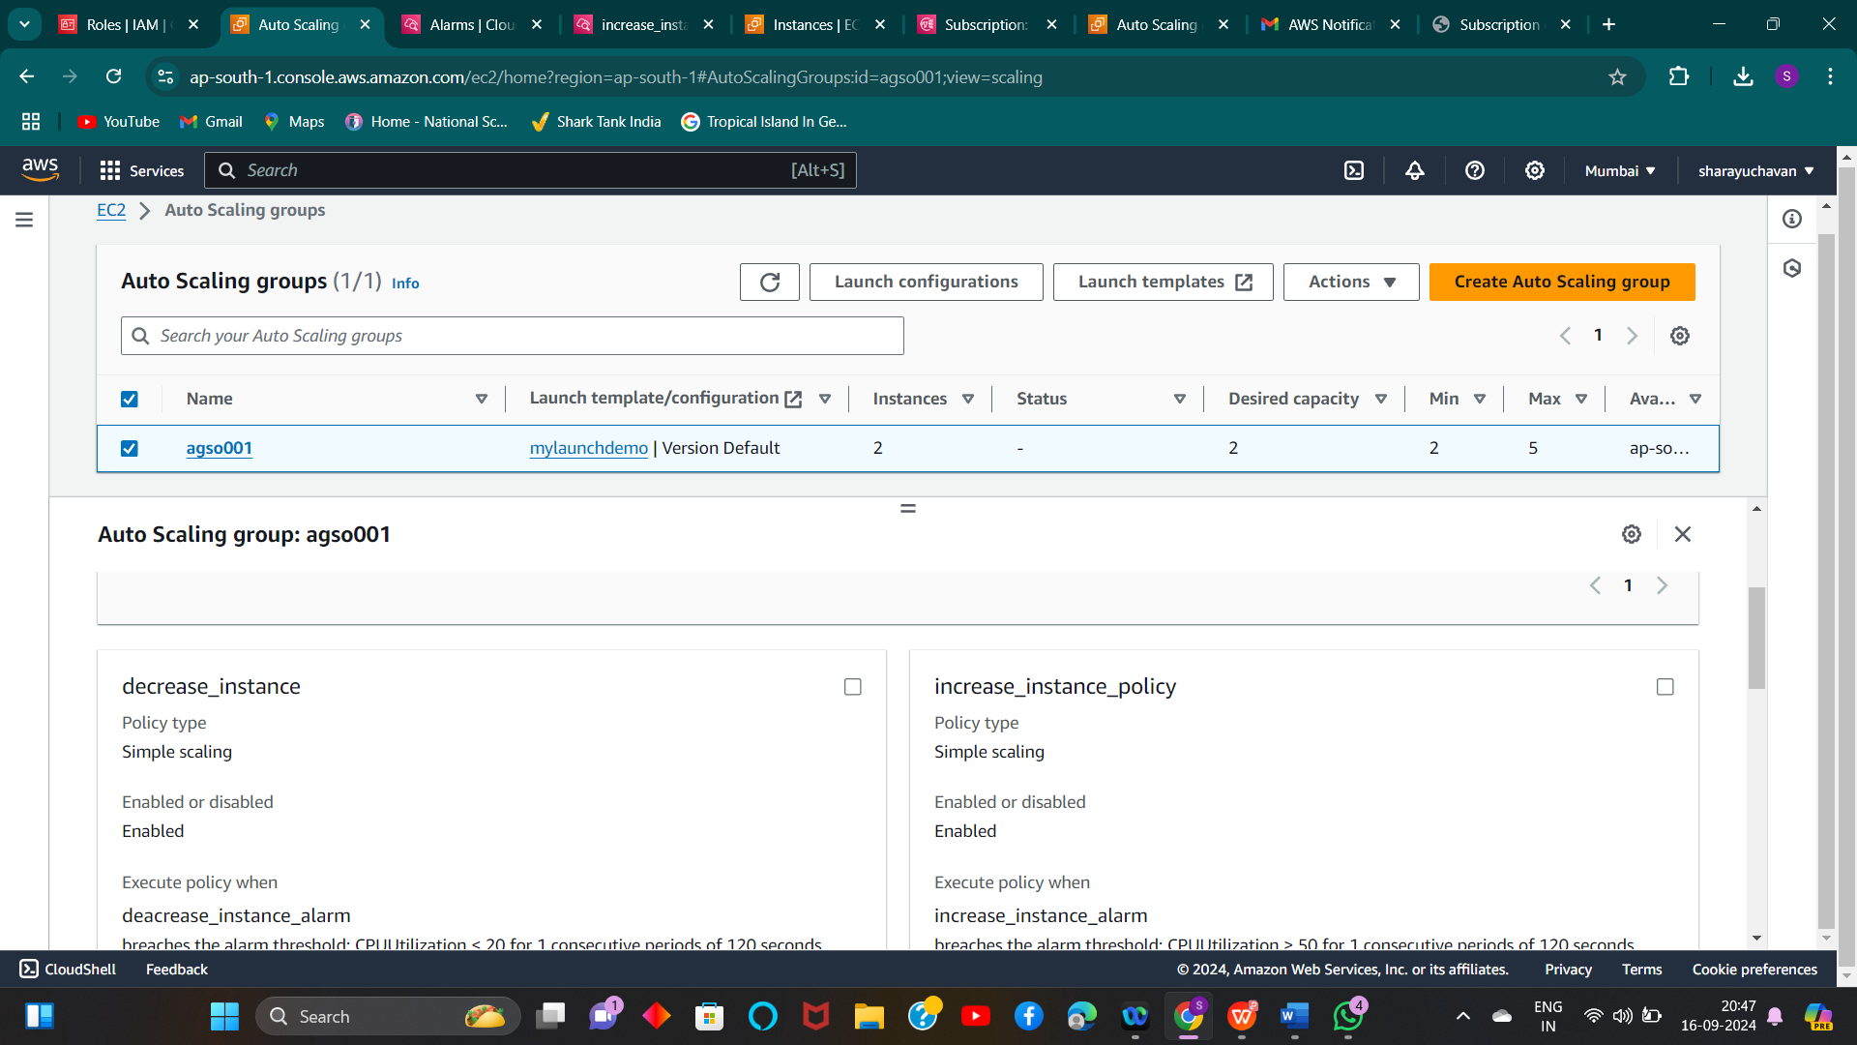

**4)** **We could see one alarm has been triggered “decrease_instance_alarm”. As checked average CPU utilization of**

**instance is below 20% only**

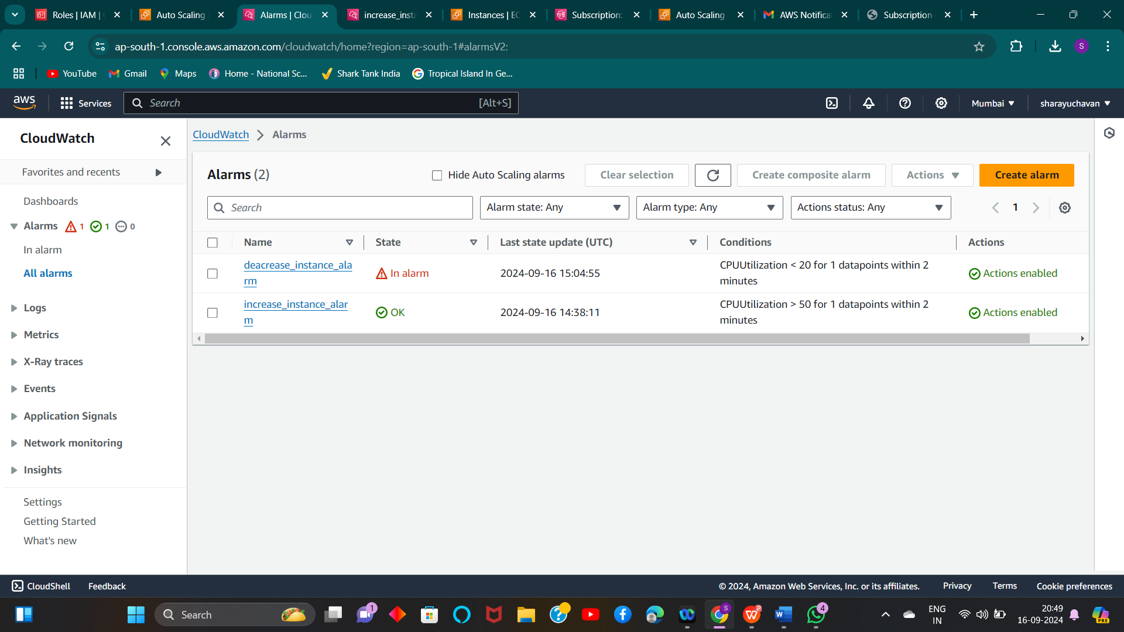

**5)** **We got notification mail**

